# How use the programe

### First open power point file you want display

## second run code

### Getrues used :

### 1: turn on slide show by using all fingeures else thump

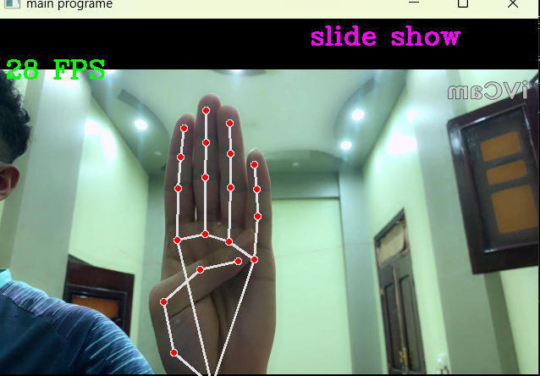

#### To go to next slide use index fingure

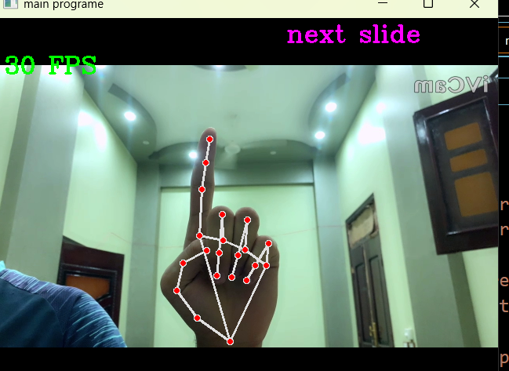

#### To go to pervios slide use index and middle fingeures

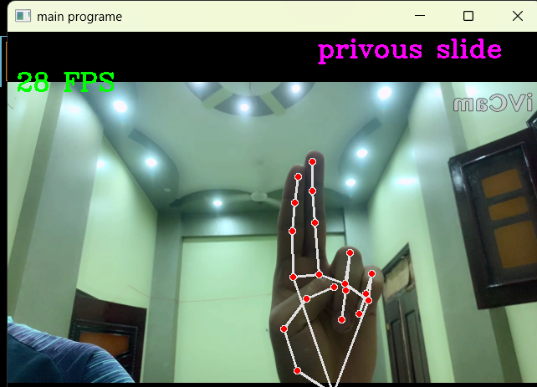

#### To start laser mode use index and thump fingeures

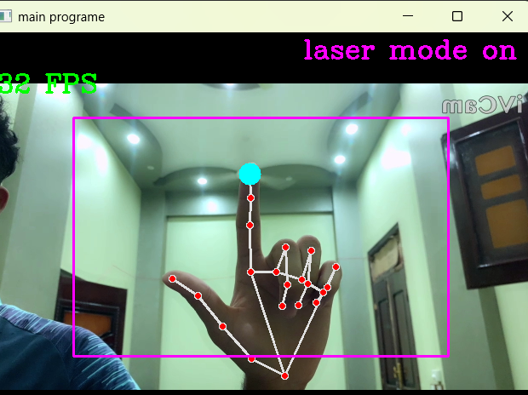

#### To End laser mode use all fingeurs

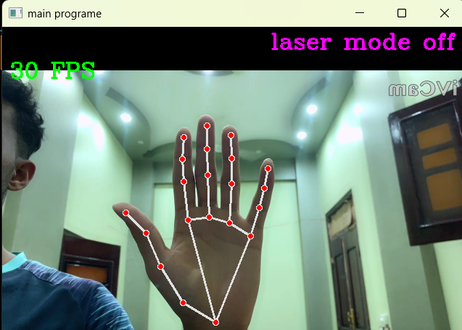

#### To Start drawing mode use index and middle and ring fingeures

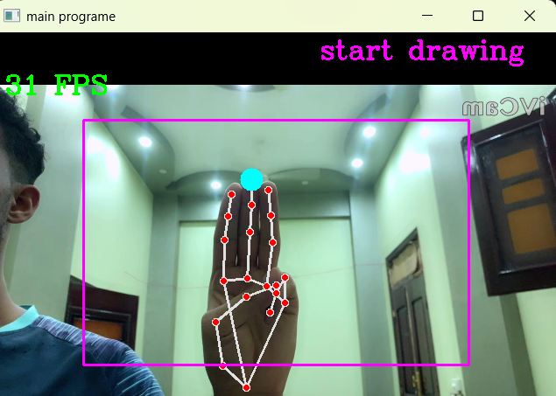

#### To End drwing mode use all fingeurs

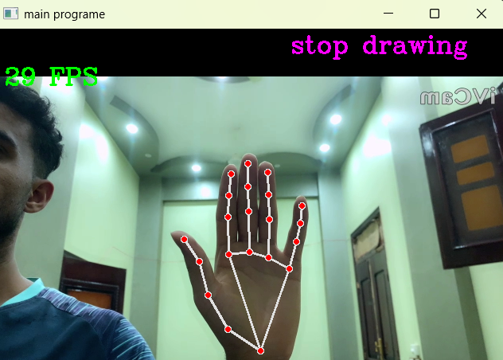

#### To start easer mode use thump and index and ring fingeurs



#### To End easer mode close all fingeurs

